# Apply filters to SQL queries

## Project description

I need to obtain specific information about employees, their machines, and the departments they belong to from the database.

My team requires this data to investigate potential security issues and to ensure that all computers are properly updated.

I am responsible for filtering the necessary information from the database.

Here’s how I’ll complete this task:

1. First, I’ll retrieve all failed login attempts that occurred after business hours.
2. Second, I’ll gather all login attempts that took place on specific dates.
3. Third, I’ll extract logins that didn’t originate from Mexico.
4. Fourth, I’ll retrieve information about selected employees in the Marketing department.
5. Fifth, I’ll pull data on employees working in either the Finance or Sales department.
6. Finally, I’ll collect information on employees who are not part of the Information Technology department.

## Retrieve after hours failed login attempts

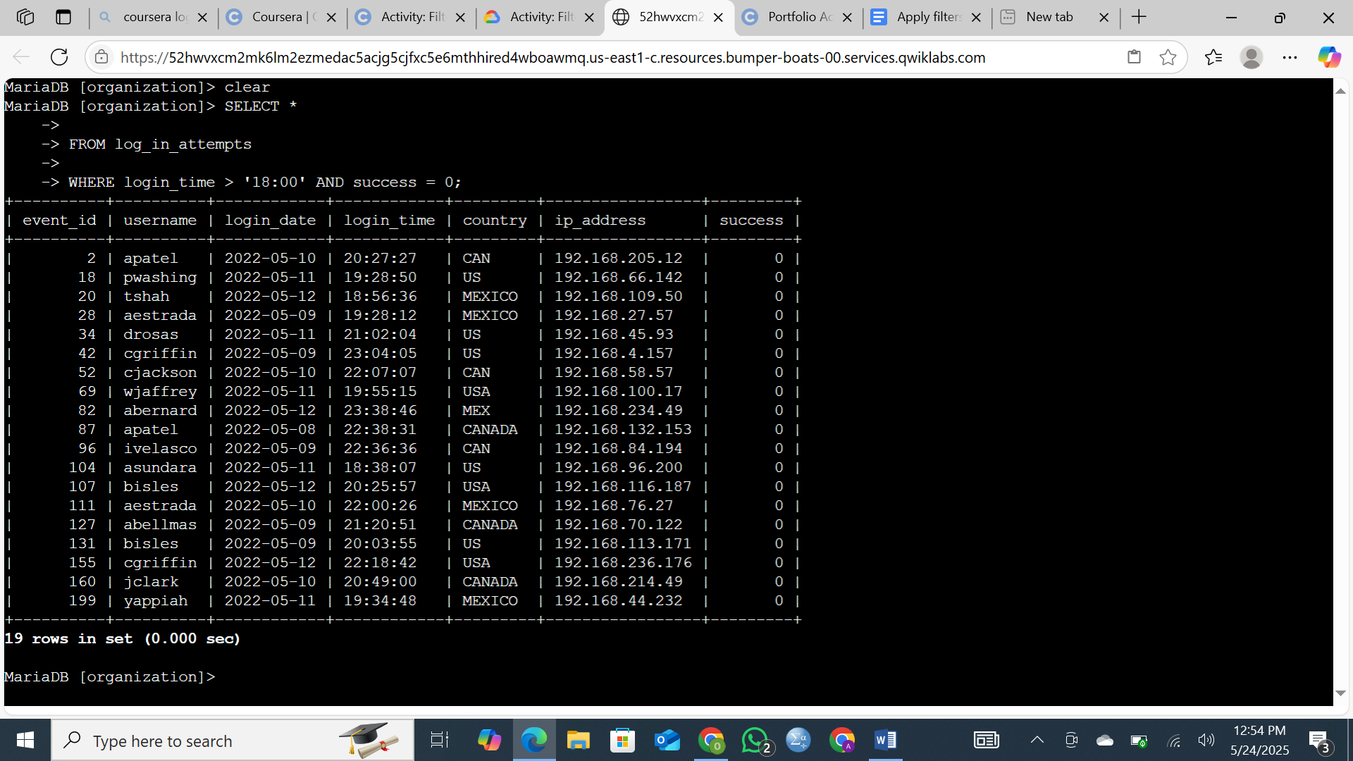

## Retrieve login attempts on specific dates

**Objective:** The team is currently investigating a suspicious event that occurred on *May 9, 2022*. To support this investigation, it is necessary to retrieve all login attempts that took place on that day, as well as the day prior (*May 8, 2022*), to identify any related activity or patterns.

**Action Taken:** I queried the log_in_attempts table to extract all failed login attempts where the login_date was either *2022-05-08* or *2022-05-09*. This was achieved using the OR operator to capture activity across both specified dates.

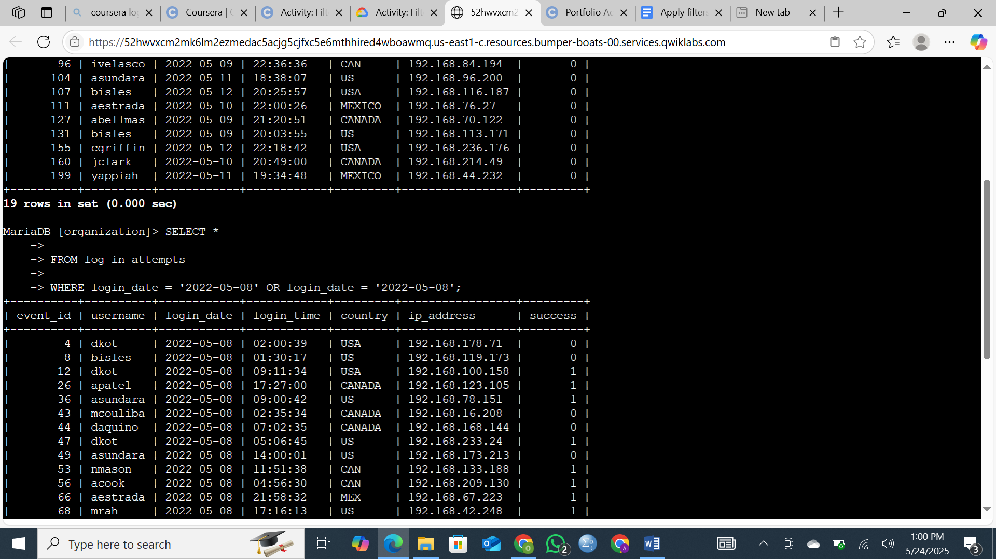

## Retrieve login attempts outside of Mexico

**Objective:** As part of a broader investigation into unusual login activity, the team is focusing on identifying all login attempts that did **not** originate from *Mexico*. This is to help assess any potential unauthorized or suspicious access from foreign locations.

**Action Taken:** To obtain the necessary data, I queried the login records using conditions that excluded any entries where the country field begins with *'MEX'*—which includes both abbreviated (*'MEX'*) and full (*'MEXICO'*) forms.

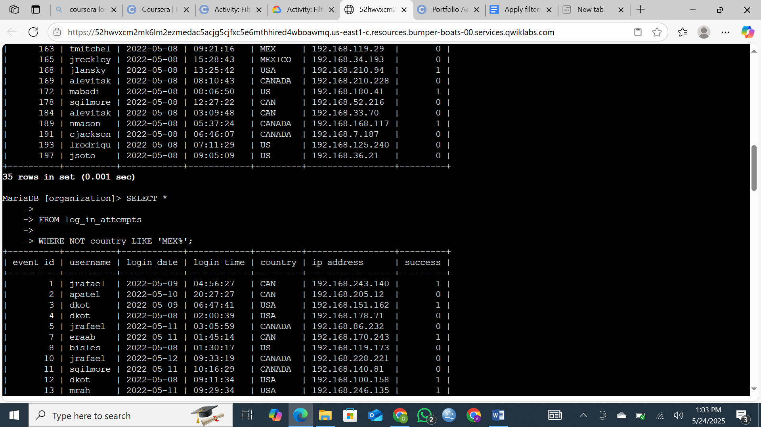

## Retrieve employees in Marketing

**Objective:** As part of the ongoing updates to employee machines, the focus has now shifted to employees in the *Marketing* department who are stationed in offices located in the *East building*. This includes all office identifiers beginning with "East-" (e.g., *East-170*, *East-320*).

**Action Taken:** I queried the employee database to retrieve information on all individuals who meet **both** of the following criteria:

* They belong to the *Marketing* department.
* They are located in offices whose identifiers begin with *East-*

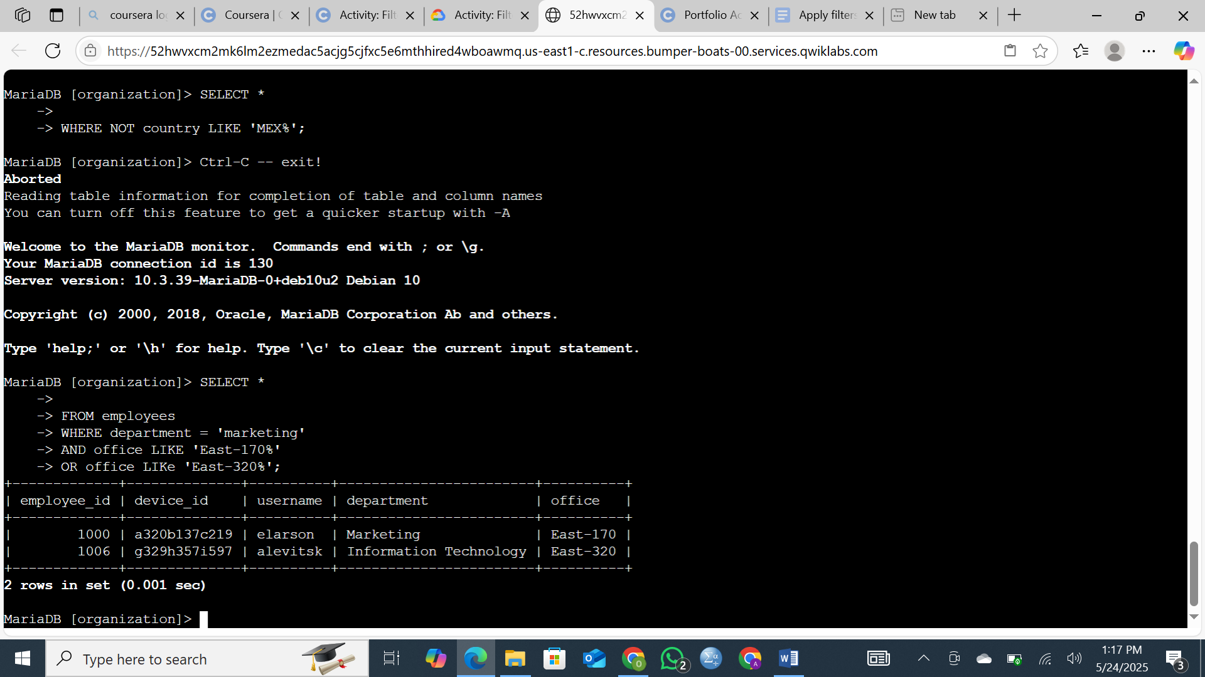

## Retrieve employees in Finance or Sales

**Objective**

The team is preparing to perform a new update targeted specifically at computers used by employees in the *Finance* and *Sales* departments. To proceed, it is necessary to locate and compile accurate information on these employees.

**Action taken** I retrieved the required records from the employee database, focusing exclusively on individuals assigned to either the Finance or Sales departments.

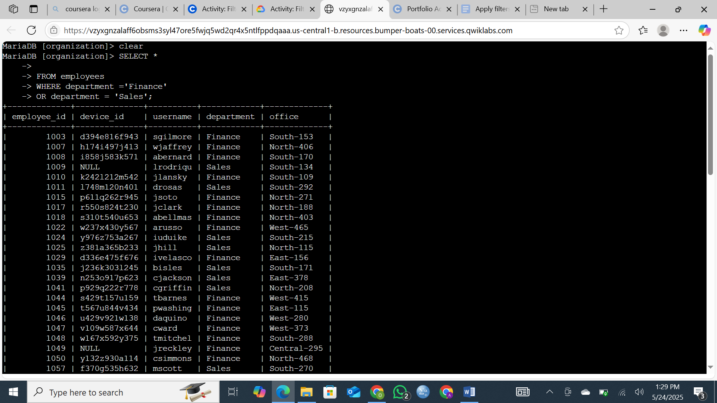

## Retrieve all employees not in IT

**objective**

The final update required by the team has already been successfully deployed to employee computers within the *Information Technology* department. To proceed with the rollout across the remaining departments, I need to identify all employees who are **not** part of the Information Technology department.

**Action taken**

To retrieve the necessary records, I used the NOT operator in a SQL query to filter out employees who belong to the Information Technology department.

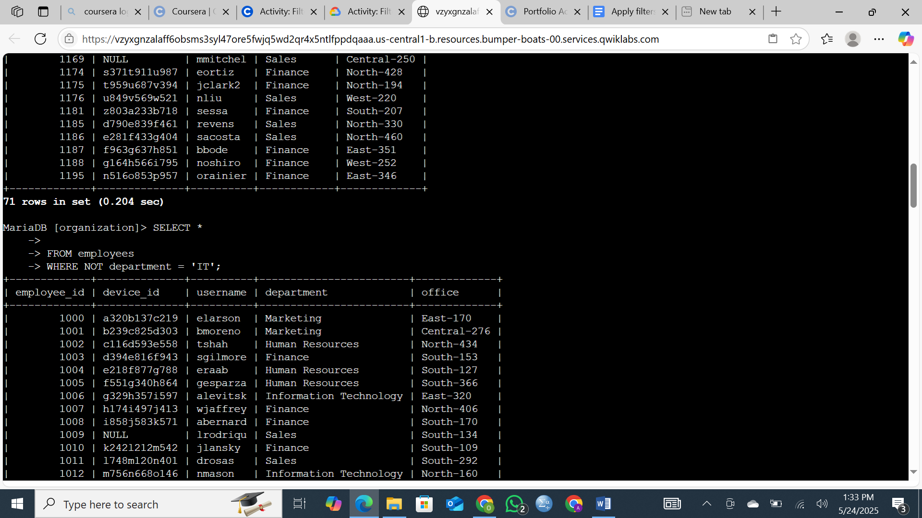

## Summary

This project focused on extracting and filtering targeted employee and login data from a central database to support system updates and security investigations. I was responsible for applying specific SQL filters to retrieve information relevant to employees, their departments, and their login activities.

Key tasks included isolating failed login attempts outside regular business hours, identifying login activity on specific dates tied to a security event, and filtering records for logins that did not originate from Mexico. Additionally, I gathered employee information for specific departments—namely Marketing (East building offices), Finance, Sales, and non-IT staff—to support the rollout of pending system updates. Each dataset was carefully filtered using appropriate SQL operators, such as NOT, LIKE, and OR, ensuring accuracy and relevance to the team’s operational and security objectives.